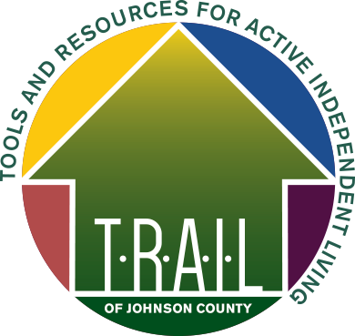

TRAIL Full Member Non-Response* Form

If I do not answer the door or the phone when a TRAIL volunteer arrives or calls for an arranged member service, I want the TRAIL volunteer to take the following action (please select one option from those listed below). If you do not want any action taken, please mark the third option below.

OPTION 1:

I would like the TRAIL volunteer to contact the individual listed below. If you elect to have us contact a family member or friend on your behalf, please let them know you have given TRAIL their information and permission to contact them.

Last Name: | First Name: | Relationship:
What phone number should we store in our system for your emergency contact? (include area code)

Email:

-OR-
OPTION 2:

I would like the TRAIL volunteer to call Johnson County Dispatch (319-356-6800), so that a police officer can perform a welfare check. The police will attempt to make contact with you. IF they do not sense this as an emergency, they will return later in the day to try to make contact. If it appears someone is home and it is an emergency situation, they will break into the house (with supervisor's permission) if no one answers.
-OR-
OPTION 3:

______ I do not want TRAIL to take any additional actions (none of the above) if I do not answer the door or
phone for an arranged TRAIL service appointment.

Member name (please print): _________________________________________________________________

Member signature: _________ _Date ______ ___________

*TRAIL does not provide emergency response services, nor are we a crisis management provider, but we will attempt to determine if an emergency situation has occurred and get help if necessary.

Date copy to TRAIL office
Revised 2.14.20

